Class 8 - Chemistry - Coal and Petroleum

Question 1:
What are the advantages of using CNG and LPG as fuels?
Answer:
The advantages of using CNG and LPG as fuels are as follows:
- They both are cleanest burning fuels of all fossil fuels.
- They are less polluting, non-corrosive.
- They can be sent through pipes easily.
- These are easily available and have affordable cost.
- LPG and CNG both are easy to store and transport.
- As there calorific value is very high therefore, they are used for cooking purpose.

Question 2:
Name the petroleum product used for surfacing of roads.
Answer:
The petroleum product used for surfacing roads is Bitumen.

Question 3:
Describe how coal is formed from dead vegetation. What is this process called?
Answer:
About 300 million years ago when the earth had dense forests in low lying wetland areas.
Due to natural processes, like flooding, these forests got buried under the soil. As more soil deposited over them, they got compressed.
The temperature also rose as they sank deeper and deeper. Under high pressure and high temperature, dead plants got slowly converted to coal.
As coal contains mainly carbon, the slow process of conversion of dead vegetation into coal is called carbonisation.
Coal Mine

Question 4:
Fill in the blanks:
(a) Fossil fuels are ___________, ________ and ______.
(b) Process of separation of different constituents from petroleum is called _______.
(c) Least polluting fuel for vehicle is _________.
Answer:
(a) Fossil fuels are Natural Gas, Coal and Petroleum.
(b) Process of separation of different constituents from petroleum is called refining.
(c) Least polluting fuel for vehicle is CNG.

Question 5:
Tick True/False against the following statements:
(a) Fossil fuels can be made in the laboratory. (T/F)
(b) CNG is more polluting fuel than petrol. (T/F)
(c) Coke is almost pure form of carbon. (T/F)
(d) Coal tar is a mixture of various substances. (T/F)
(e) Kerosene is not a fossil fuel. (T/F)
Answer:
(a) Fossil fuels can be made in the laboratory. (False)
Reason: - Fossil fuels are formed from dead remains of living organisms.
(b) CNG is more polluting fuel than petrol. (False)
Reason: - CNG is the cleanest fuel.
(c) Coke is almost pure form of carbon. (True)
(d) Coal tar is a mixture of various substances. (True)
(e) Kerosene is not a fossil fuel. (False)
Reason: - Kerosene is a fossil fuel, as it is obtained by fractional distillation of crude oil.

Question 6:
Explain why fossil fuels are exhaustible natural resources.
Answer:
The formation of fossil fuels is a very slow process, it takes millions of years.
There are limited reserves of fossil fuels in nature.
Fossil fuels are exhaustible natural resources, as limited fossil fuels reserves like coal, petroleum, natural gas
are being depleted very fast by human activities like rapid urbanization, industrialization and transportation.

Question 7:
Describe characteristics and uses of coke?
Answer:
Coke is a tough, porous and black substance. It is almost pure form of carbon.
It is produced by destructive distillation of coal.
Following are the characteristics of coke:-
- It is used for extraction of metals (as a reducing agent).
- It is used in the manufacture of steel.
- It is used as domestic as well as an industrial fuel in stoves and furnaces.
- It gives little or no smoke.
Question 8:
Explain the process of formation of petroleum.
Answer:
Petroleum was formed from organisms living in the sea.
As these organisms died, their bodies settled at the bottom of the sea and got covered with layers of sand and clay.
Over millions of years, absence of air, high temperature and high pressure transformed the dead organisms into petroleum and natural gas.
The petroleum deposits are usually found mixed with salt water. The petroleum is lighter than salt water, and hence, floats over it.
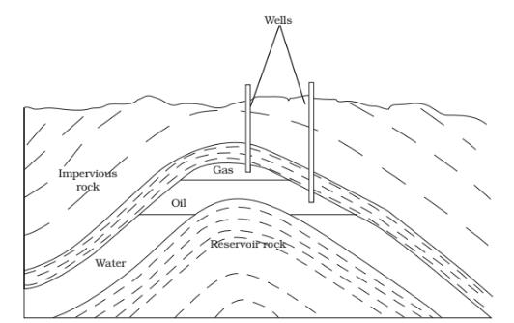
Question 9:
The following Table shows the total power shortage in India from 1991–1997. Show the data in the form of a graph.
Plot shortage percentage for the years on the Y-axis and the year on the X-axis.
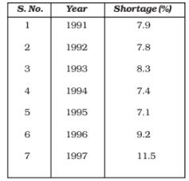
Answer:
Total Power Shortage in India

